**ASSIGNMENT 3:**

**Module 4: Functions & Modules in Python**

**Task 1: Calculate Factorial Using a Function**

**Problem Statement:** Write a Python program that:

1. Defines a function named factorial that takes a number as an argument and calculates its factorial using a loop or recursion.

2. Returns the calculated factorial.

3. Calls the function with a sample number and prints the output.

**Expected Output:**For example, if the function is called with 5, it should return:

|  |  |
| --- | --- |
|  |  |

**Task 2: Using the Math Module for Calculations**

**Problem Statement:** Write a Python program that:

1. Asks the user for a number as input.

2. Uses the math module to calculate the:

o Square root of the number

o Natural logarithm (log base e) of the number

o Sine of the number (in radians)

3. Displays the calculated results.

**Expected Output:** For example, if the user enters 25, the output should be:

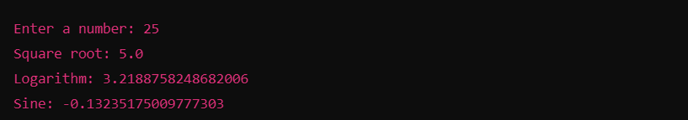

**Submission Instructions:**

* Create a **GitHub repository** and upload your Python scripts (.py files).
* Ensure the repository includes a **README.md** file that describes the functionality of your programs.
* Add both **Task 1 and Task 2** scripts in the same repository.
* Submit the **link to your GitHub repository** once uploaded.

**Reference:**

Follow the **Python course - Module 4: Functions & Modules in Python** for additional guidelines and examples.

**Note:**

**Please test your project thoroughly and check all the validations and error handling prior to ensure it works as expected before submission.**

**You can always connect to the mentor using the chat support option for any doubts or queries!**